

**V4.7**

**USER’S MANUAL – August 2025**

**ENERGY SYSTEMS LABORATORY**

Texas Engineering Experiment Station

The Texas A&M University System

 

# Introduction

The International Code Compliance Calculator (IC3) software is a simple, performance based, software tool for verifying that proposed new residences in Texas (of three stories or less) are in compliance with the Texas Building Energy Performance Standards (TBEPS). The IC3 verifies compliance using either the Simulated Performance Alternative Path or the Energy Rating Index Compliance Path criteria in the International Energy Conservation Code (IECC). The software is web-based and available at no charge, for builders, inspectors, architects, engineers, and others.

With the intention to cover the majority of residences that are built in Texas, the IC3 focuses on residential construction of three stories or less which uses conventional wood framing, foundation systems of slab on grade, pier and beam, or raised floors, and that has between 100 to 10,000 square feet of conditioned space per floor. Other types of residential construction such as steel framing, mass (concrete, CMU blocks, logs and insulated concrete forms) may not be candidates for this software and the User should contact the local building official for other energy code compliance options.

The IC3 uses simplified singular inputs, which encourage weighted averages for various energy components with multiple values, including wall and ceiling insulation, windows, ceiling heights and multiple A/C tonnages. Energy compliance for repairs and remodels of existing construction may be demonstrated with this software only if the repairs/additions are included as a whole house approach.

The IC3 calculates the above code performance of a new home and how much pollution is reduced (emissions reduction) by the home’s energy efficiency. For projects that meet or exceed the Texas Building Performance Standards, the IC3 generates a detailed seven-page climate zone specific field inspection list, a three-page energy report (with/without a signature block), as well as a certificate. All of the documents are generated in a PDF format and may be saved to the user’s PC.

## Background

The Federal Clean Air Act (FCAA) requires each state to produce and regularly update a State Implementation Plan (SIP). The FCAA also requires that SIPs include a description of control strategies, or measures to deal with pollution, for areas that fail to achieve national ambient air quality standards (NAAQS). Finally, this Act grants powers of enforcement to the United States Environmental Protection Agency (EPA).

The EPA originally designated four areas in Texas as having unacceptable ozone levels in excess of the National Ambient Air Quality Standard (NAAQS) limits, leading to a designation as non-attainment areas.

In response, the 77th Texas Legislature’s Senate Bill 5 (2001) established the Texas Emissions Reduction Plan (TERP). An element of the TERP is the Texas Building Energy Performance Standards (TBEPS) which adopts energy codes and provides implementation steps. This legislation assigned the Energy Systems Laboratory (ESL) at the Texas A&M Engineering Experiment Station several important roles, including calculation of emissions reduction from energy efficiency and renewable energy programs and initiatives and providing state-wide technical assistance regarding energy standards/codes to the state, municipalities and the building industry.

The ESL has developed several web-based energy efficiency and emissions reduction calculators including Texas Climate Vision (TCV) developed for Austin, TX, and the legacy calculators; eCalc and AIM. The IC3 is used to benchmark the estimated energy performance of new residential and multifamily construction in Texas of three stories or less, and is available via the internet to the general public at no charge.

The ESL is working with the different Councils of Government in Texas to develop a verification mechanism in order to maximize SIP Credits by aggregating emissions reduction accomplished by above-code-compliance.

## Requirements

1. Browser: Microsoft Internet Explorer v11+ or Mozilla Firefox v45+

2. Adobe Acrobat Reader DC 15+ or Adobe Acrobat X or later (to view/print/save the certificates and energy reports which are dynamic .pdf format)

Contents

[Introduction 1](#_Toc14096334)

[Background 2](#_Toc14096335)

[Requirements 2](#_Toc14096336)

[What’s New! 5](#_Toc14096337)

[Common Screens 7](#_Toc14096338)

[User Login Screen 7](#_Toc14096339)

[User Resets Password 8](#_Toc14096340)

[User Registration 9](#_Toc14096341)

[Main Page 10](#_Toc14096342)

[New Project 12](#_Toc14096343)

[Delete Project 12](#_Toc14096344)

[Copy project 13](#_Toc14096345)

[Single Family Projects 14](#_Toc14096346)

[Single Family Project Screen for Performance Path 14](#_Toc14096347)

[Single Family Project Screen for ERI Path 15](#_Toc14096348)

[Mode Selection 16](#_Toc14096349)

[Project Data 16](#_Toc14096350)

[Error List 18](#_Toc14096351)

[Submit Project 19](#_Toc14096352)

[Global Parameters 20](#_Toc14096353)

[Supplemental Panels 24](#_Toc14096354)

[Testing 25](#_Toc14096355)

[Roof 29](#_Toc14096356)

[Foundation 32](#_Toc14096357)

[Heating 33](#_Toc14096358)

[A/C 35](#_Toc14096359)

[Water Heater 36](#_Toc14096360)

[Appliances (ERI mode Only) 38](#_Toc14096361)

[Floor Plan Details 39](#_Toc14096362)

## What’s New!

**In version 4.0 – June 15, 2015**

1. Initial release with single family for IECC 2015

**In version 4.0.1 – July 31, 2015**

1. The original version (4.0) printed the logged in user’s name, phone number, and email address in the builder’s fields on the certificate and energy report. These can now be overridden on a project-by-project basis. The new input fields on the left side of the screen are now the values that will be printed on the certificate and energy reports.
2. The project notes will now appear on the Energy Report. Due to spacing issues, only the first 60 characters will be printed. If the project notes are longer, they will be truncated in the energy report.
3. On a user’s main user screen (the one immediately after login that lists all projects), a button has been added to the top: ‘Edit User Information’. This button allows the logged in user’s contact information.
4. On a user’s main user screen a button has been added to the top: ‘Import Project from IC3 version 3.x ’. Several users have requested the ability to ‘import’ projects from the old version of IC3.
5. Users will be prompted to enter their IC3 version 3.14 credentials and the select a project to import. Only single-family project import is available at this time.
6. The user will be prompted for a new project name, project address, and orientation (similar to copying an existing project from version 4.0).

Aside from these fields, the project is copied without alteration *except* that the code is changed to IECC 2015. Some rounding issues on the energy Report have been fixed.

**In version 4.1 – September 1, 2016**

1. Initial release of Energy Rating Index (ERI) calculation

**In version 4.2 – October 15, 2016**

1. Added NCTCOG 2015 IECC amended code to the list of available codes

**In version 4.3 – Merch 11, 2017**

* Added 2015 Austin Energy Amendments to list of codes
* Altered the duct model to improve accuracy. Details here.

**In version 4.3.1 – July 22, 2017**

* Added NCTCOG 2015 ERI amendment to list of codes

**In version 4.4 – July 2, 2019**

* Updated weather files. This increases the temperature slightly and will increase energy usage in the summer months
* Major update of ERI calculation to reflect the changes made to RESNET HERS rating algorithm  
  Important: The amount of calculation needed for this calculation has more than doubled. An ERI calculation will now take up to 1 minute to complete.

**In version 4.4.1 – July 11, 2019**

* Bug fixes

**In version 4.4.3 – July 18, 2019**

* Bug fixes

**In version 4.5 – September 29, 2019**

* IECC 2018 code added
* New equipment: Tankless NGas DHW

**In version 4.5.6 – Nov 29, 2021**

* IECC 2021 AE code added
* IECC 2021 code added
* New equipment: DHW UEF, New Duct System Interface

**In version 4.5.7 – May 23, 2022**

* New search features added in project page
* Alterations made to 2021 Energy Option selection

**In version 4.5.8 – September 6, 2022**

* New ceiling energy model added
* Bug fixes

**In version 4.5.10 – January 23, 2023**

* IECC 2021 NCTCIG released

**In version 4.6 – September 23, 2024**

* New DHW model for 2024 IECC
* New inputs for 2024 ERI
* New AE inspection sheet
* Bug Fixes

**In version 4.7 – August 4, 2025**

* Update DHW model
* Added Tankless Electric DHW for 2021
* Bug Fixes

# Common Screens

## User Login Screen

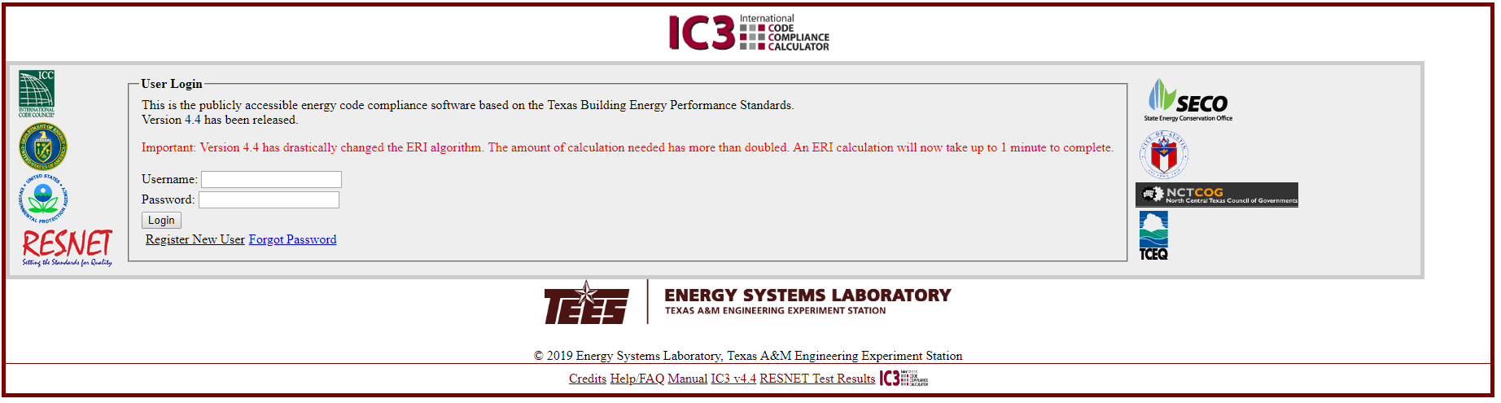

**The current version of the software is found here**

Users, who have registered on the current version of IC3, simply enter the Username and Password in the spaces specified and left-click on the “Login” button to be connected to the “**Main Page**”.

If the user has forgotten or needs to change their password, left-click on the “Forgot Password” link to be led through the secure process of changing a password.

A User who has not registered on the current version of IC3, left-click on the “Register New User” link the user will be redirected to the “User Registration” page.

## User Resets Password

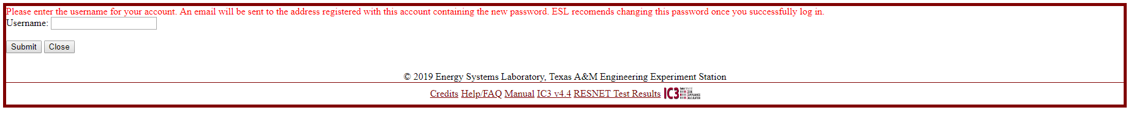

To reset a password, a user simply enters the email address that was used to register. The system will send the user an email with instructions to reset the account. To reset a password without the registered email account, please contact customer service at: [esl\_e2calc\_support@tees.tamus.edu](mailto:esl_e2calc_support@tees.tamus.edu).

## User Registration

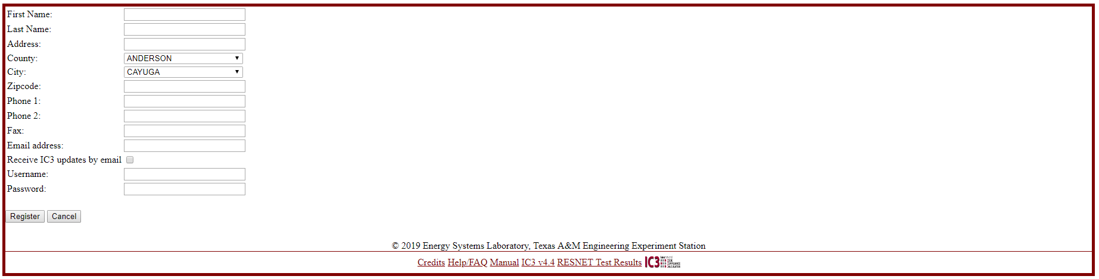

After clicking on the **“Register New User” button** on the “**Login Page”** page, a new User may register the first time they use IC3. A user who is registered with IC3 version 3.14 (for IECC 2012 and earlier) must re-register in this new system.

Note: Usernames in the new system should not be an email addresses. Email addresses change over time.

The information provided is the contact information that ESL uses to contact you directly. It should be kept updated.

Checking the receive IC3 updates by email box permit the ESL to send IC3 update information on new releases, updates and scheduled outages.

ESL will never sell contact information to a third party, nor deliver emails, other than official IC3 information, to this email address.

Once the page is successfully completed, the user is taken to **“Main Page.”**

## Main Page

**Navigation**

**Search**

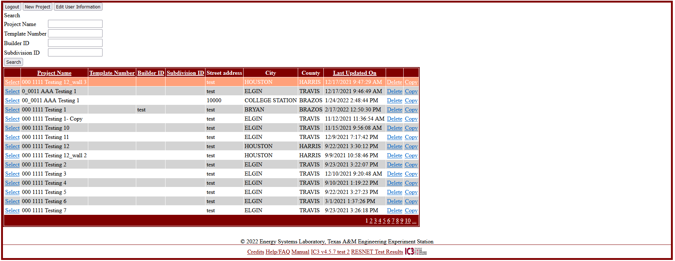

**Project Page Selection**

**Project Actions**

Once logged on, the user’s “**Main Page**” will appear. This page allows management all of the user’s projects in IC3.

There are several buttons along the top of the page:

* Logout: returns to the “**Login Page**”. Also, inactivity by a user for more than 10 minutes will automatically logout the user.
* New Project: Start a new project.
* Edit User Information: Edit contact information.

The table lists all of the projects that are currently associated with this account. Each line in the table is a separate project in the database. Navigate the pages by selecting the page number at the bottom right.

By default they are ordered alphabetically by Project Name. Projects can be sorted by Last Updated Date. Clicking either link in the table’s title row will cause the table to resort.

The User can also search for keywords within the project. Enter a word or phrase corresponding to a field into the search box and click the Search button. The table will reload and will now contain only those projects with that word or phrase in their title. Selecting multiple boxes will list projects containing all entered phrases, ex: entering ‘first in project name and ‘221’ in builder id will cull the list to only those projects by builder 221 containing the phrase ‘first’ in the name. Clearing all the boxes and clicking search will restore the list of all projects.

Each project line has 3 links:

* Delete: The project will be deleted project using the “**Delete Project**” procedure
* Copy: A duplicate project will be created using the “**Copy Project**” procedure
* Select: The project opens to allow editing and printing of energy reports and other documentation using the “**Single Family Project**” screen

## New Project

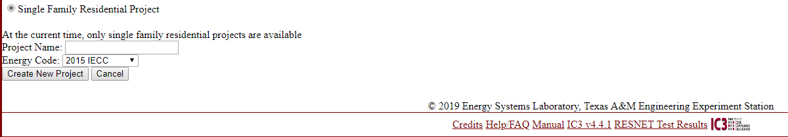

Creates a new project.

Only single family projects are available, at the current time.

Project Name must be unique for a user. Each case need select which code you will apply. Right now we have 2018 IECC, 2015 IECC, 2015 IECC AE (Austin Energy), and 2015 NCTCOG (North Central Texas Council of Governments) code appliance.

Once created you will be taken to the newly created project’s **Single Family Project**” screen.

## Delete Project

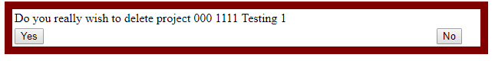

If the delete link is clicked, to the user must acknowledge that deletion of the project is requested. Once a project is deleted, it is removed from the system and is not recoverable by the user or the ESL.

## Copy project

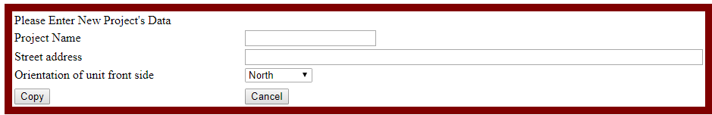

When copying an existing project, a new project name, street address, and orientation must be created.

The new project name must be unique for a user. The name and street address should be appropriate for the new project.

Other details and information from the copied project remains.

# Single Family Projects

## Pre-2021 Single Family Project Screen for Performance Path

**PERFORMANCE PATH**

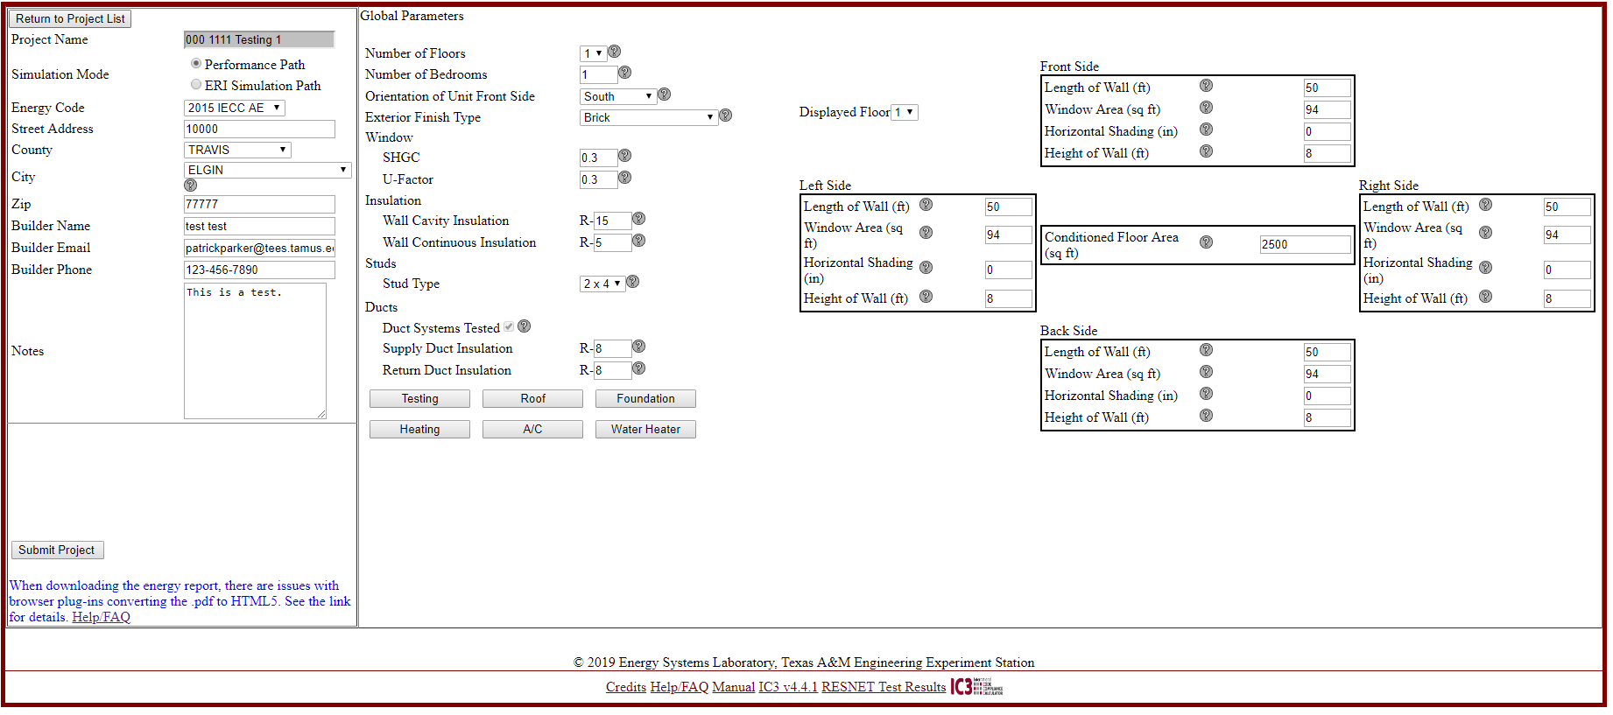

## Pre-2021 Single Family Project Screen for ERI Path

**ERI PATH**

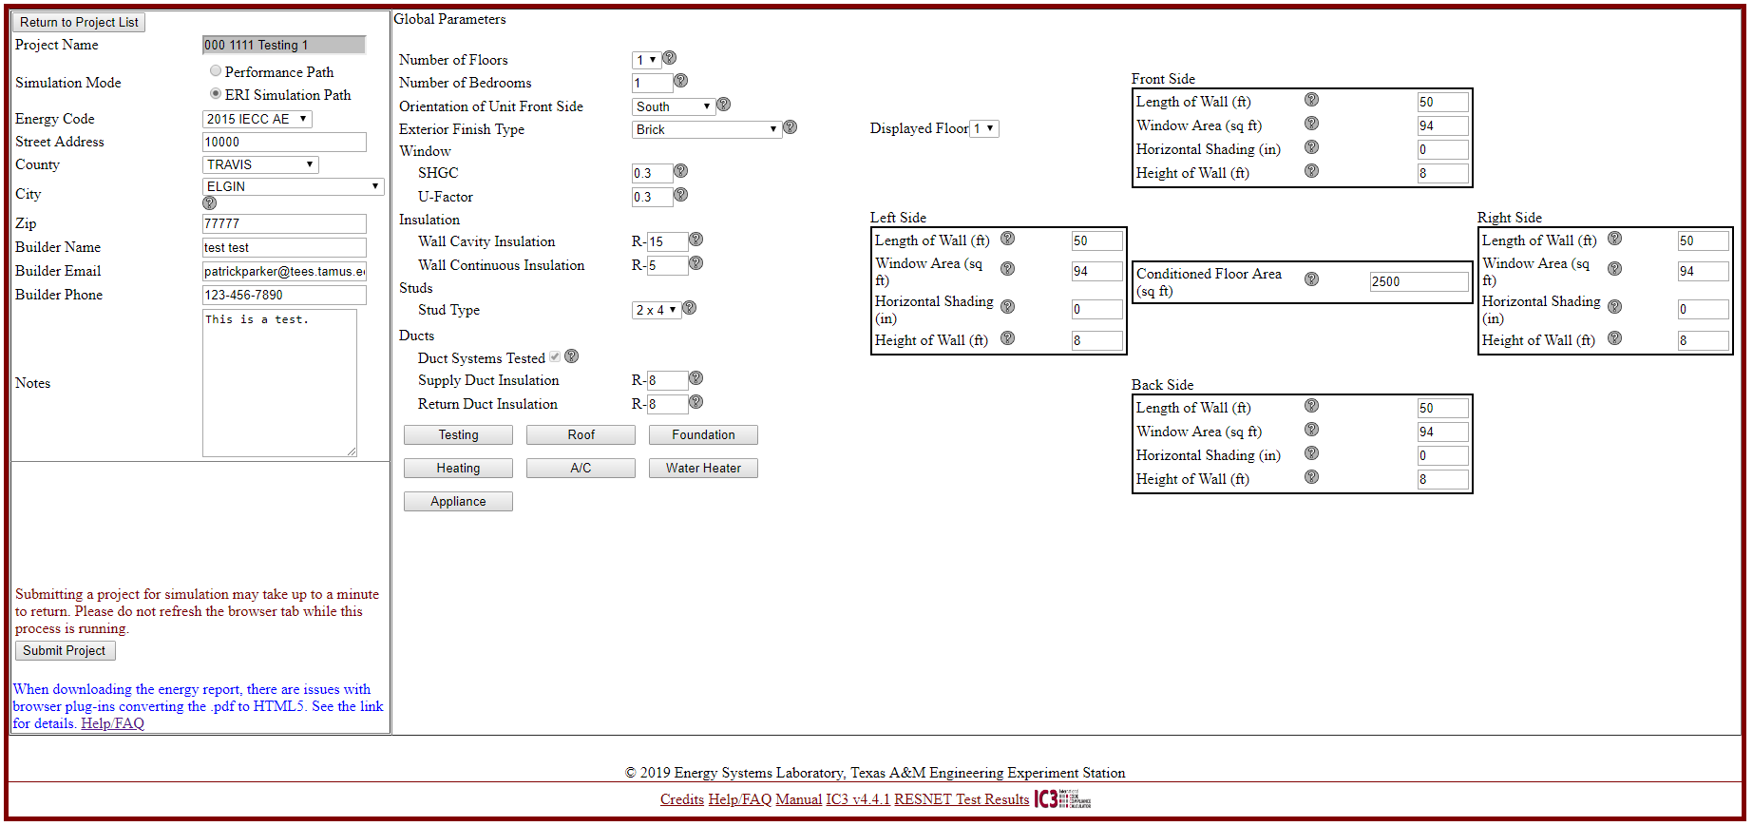

**aPPLIANCE IS EXCLUSIVE FOR ERI PATH**

## Post-2021 Screen

The screens remain identical when dealing with a 2021 code, but The Mode selection has changed. This mode selection mode will be enabled on all projects when first starting. See the next section below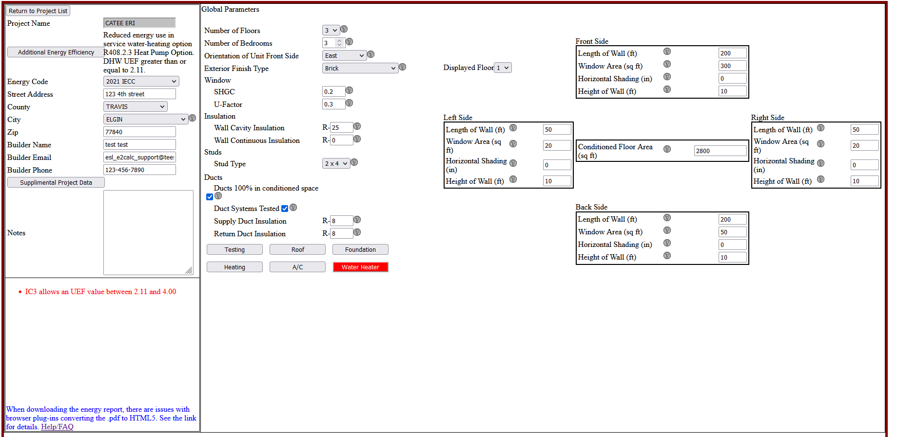

This screen consists of several parts:

## Mode Selection Pre-2021

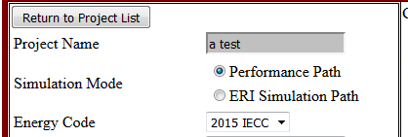

Immediately under the return to Project List button, is the mode selector

* Select Performance Path to run an IECC Simulated Performance. A selection box labeled ‘Energy Code’ will appear populated with all currently available energy codes. Select the appropriate one.
* Select ERI Simulation Path to run an Energy Rated Index simulation in accordance with ANSI/RESNET/ICC 301-2014.

## Mode Selection Post-2021



**Current Option**

**Button to change Option**

## At the start of a new project or whenever the Energy Efficiency Option is selected, a new screen appears to set the energy option as described by IECC 2021 section R408

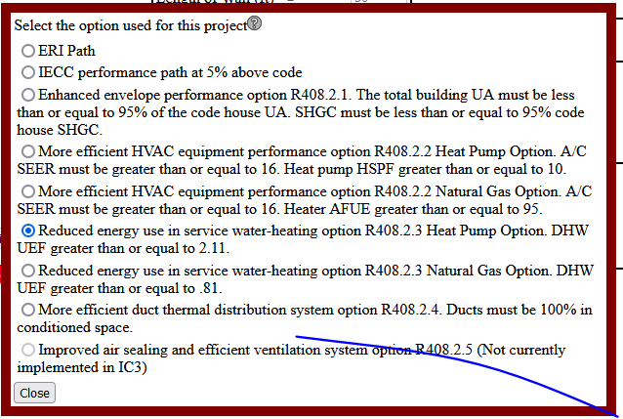

Each option is described below:

* ERI Path: A standard ERI Path based on the specifications set forth by the Texas legislature. This does not, in general, refer to the IECC and so is unaffected by this section. It remains basically unchanged from previous versions.
* IECC performance path at 5% above code: This is the base 2021 IECC code without selecting an option from section R408. Based on the requirements given in IECC 2021 R401.2.5, a project must meat a requirement of 5% above code to pass in this mode.

All further selections refer to one of the options given in IECC 2021 section R408. The requirements for these options must be met, but after doing so the project only need to meet a requirement of 0% above code to pass.

* R408.2.1 Enhanced envelope performance option: The total UA of the proposed house must be less than 95% of the code house UA. As the total UA is calculated from several different inputs, it will not be calculated until the project is submitted. In this mode there are 3 options to submitting a project:
  + Project is less than 0% above code: failure
  + Project meets the UA requirement and is above code: Pass
  + Project is above code but fails to meet the UA requirement: This will fail but give a message stating that the reason is failure to meet the UA requirement. It will be necessary to increase the envelope efficiency to pass in this case.
* R408.2.2 More efficient HVAC equipment option: minimum of 16 SEER or A/C and 95 AFUE or 10 HSPF for heating systems. Electric resistance heating is prohibited. These new buffers will be reflected on the input screen
* R408.2.3 Reduced energy use in water heater option: Requires a use of a heat pump DHW (only) with an UEF of at least 2.11. These changes will be reflected in the inputs screen.
* R408.2.4 More efficient duct thermal distribution system. Due to current limitations of IC3, the only way to satisfy this option is for the ductwork to be set 100% in conditioned space. This change is reflected on the input screen.
* R408.3.5 Improved air sealing and efficient ventilation systems model: IC3 cannot currently implement this option.

## 

## Project Data

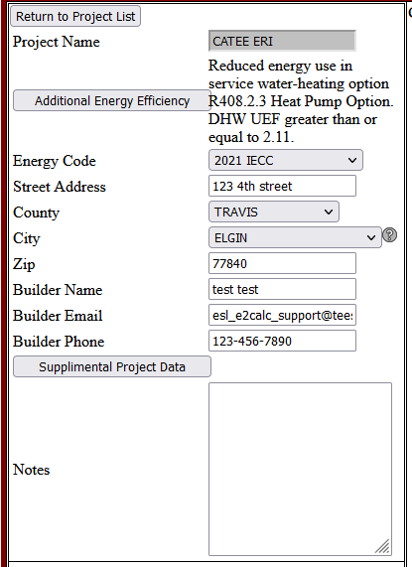

| **TITLE** | **PICTURE** | **RANGE** | **GUIDANCE** | **NOTES** |
| --- | --- | --- | --- | --- |
| **Project Name** |  |  | Enter a unique name for your proposed project. |  |
| **Simulation Mode** | Street Address of the Project | *Radio Button :*   * Performance Path * ERI Simulation Path | Select Performance Path or ERI Simulation Path |  |
| **Energy Code** | *Drop Down Menu:*   * 2015 IECC * 2015 IECC AE * 2015 NCTCOG * 2018 IECC | Choose the energy code version accepted by the authority having jurisdiction for the location of construction. |  |
| **Site Street Address** | NA | Enter the address of the unit. |  |
| **County** | *Drop Down Menu:*  List of 252 counties in Texas | Select the county in which the unit will be built. |  |
| **City** | NA | Enter the city in which the unit will be built. |  |
| **Zip Code** | NA | Enter the zip code in which the unit will be built. |  |
| **Builder Name** | NA | Enter the name of the client. |  |
| **Builder Email** | NA | Enter the Email of the client. |  |
| **Builder Phone** | NA | Enter the phone number of the client. |  |
| **Supplemental Project Data** | NA | Opens the supplemental project data panel |  |
| **Notes** | NA | Add any other notes about the unit you would like to add. | Limit the notes to 255 characters. |

At the upper left section of the page is the project data screen. This consists of the generic data (address, builder data, etc.) for the project.

It is critical that the county and zip code are correct for the project to determine the correct weather file. When a county is selected, the city drop-down list will populate with known cities in the county. Within each list, there is an entry ‘unincorporated’. If your city does not appear in the list, select ‘unincorporated’. The county is the determining factor, not the city. Please contact customer service at [esl\_e2calc\_support@tees.tamus.edu](mailto:esl_e2calc_support@tees.tamus.edu) and to provide information on missing county-city combinations that are missing from the database.

The builder information is printed on the energy report by default. When a new project is created, the logged-in user’s contact information is used. The default information can be edited prior to printing the energy report.

The notes section is provided for additional project data that you want to include. These notes will appear on the energy report.

## Error List

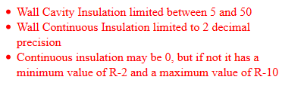

The error list is at the bottom left of the page, below the project data. This is a list of all displayed data that is incorrect. Errors often are a result of a value that is out of acceptable range. Acceptable ranges for values are dependent on the selected IECC code.

Errors that occur in the supplemental panel information will color red the access button to the supplemental panel containing the error.

A report may not be submitted until all displayed errors in the list and in the supplemental panels have been corrected.

## Supplemental Project Data

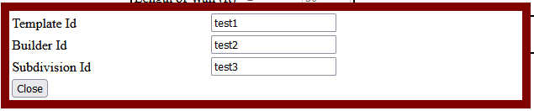

This panel allows entry of the supplemental project data. This has no effect in the score of the project at all. It is only used to manage the search feature in the main project screen.

## Submit Project



The submit project button will appear when all input errors have been resolved. Once the Submit Project button is clicked, the project will be submitted to the DOE2 calculation engine. A message stating the project is above or below code will appear once the simulation is complete.



In performance mode, if the project returns with a percent above code > 0% (passing), three print buttons will appear.

In ERI mode, if the project returns with a passing ERI <= the maximum ERI as set by the Texas legislature, three print buttons will appear.

* Print Certificate: prints a small certificate for placement in the residential electrical panel.
* Print Energy Report: prints a detailed energy report on the project, for submittal to the jurisdiction for permitting.
* Inspection Form: an official Department of Energy (DOE) IECC inspection form based on climate zone. Note: this form is provided by the DOE.

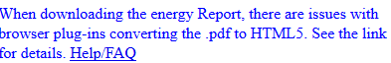

The energy report uses a new format called ‘dynamic pdf’. Adobe Acrobat or Adobe Reader DC operates in the new format. If the user pdf converter is having a problem downloading the energy report, set the browser to open the Energy Report in one of the above Adobe products, rather than be handled ‘internally’.

How to instructions are different for every browser. Detailed instructions can be found by clicking the Help/FAQ link.

The right side of the screen is where of the majority of the project data is entered.

Detailed help information can be obtained by clicking the ‘question mark icon’ after each field. Any field outside of acceptable range will have a red asterisk, and a message will appear in the Error List.

## Global Parameters

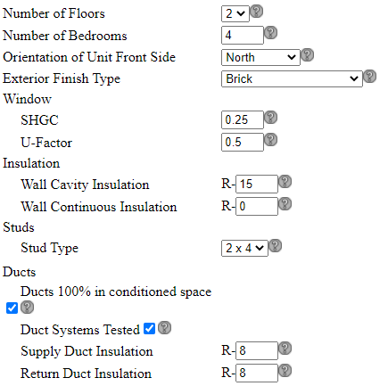

| **TITLE** | **PICTURE** | **RANGE** | **GUIDANCE** | **NOTES** |
| --- | --- | --- | --- | --- |
| **Number of Floors** |  | *Drop Down Menu:*   * 1 * 2 * 3 | Select the number of floors the unit will have. | On selecting either two or three floors, the page expands to show fields for second and / or third story entries.  Split level units are not modeled at this time.  First floor displays regardless of selection of the number of floors. |
| **Number of Bedrooms** |  | 1 – 10 | Enter the number of bedrooms the unit will have. | A room without an external window or door and closet is not to be counted towards this value. |
| **Orientation of Unit Front Side** |  | *Drop Down Menu:*   * South * Southwest * West * Northwest * North * Northeast * East * Southeast | Select the orientation of the unit. | The front of the unit is the direction the front door faces. The right side of the Unit is to the right of the front door when facing it. |
| **Exterior Finish Type** |  | *Drop Down Menu:*   * Stucco * Vinyl Siding * Brick * Fibrous Cement Board * Wood Siding | Select the exterior wall finish from the drop-down menu. | If your siding type is not listed, please choose the closest material for an approximation. |
| **Solar Heat Gain Coefficient** |  | 0.01 – 0.99 | Enter the Solar Heat Gain Coefficient (SHGC) for the fenestrations (e.g., windows and doors). | If the house has different values, the user either enters the highest value or calculates a weighted average based on square footage.  Appropriate SHGC-values can be found in Table R402.1.2 of the IECC 2015. |
| **U-factor** |  | 0.01 – 1.5 | Enter the U-Factors of fenestration products (e.g., windows and doors). | If the house has different values, the user either enters the highest value or calculates a weighted average based on square footage.  Appropriate U-factor values can be found in Table R402.1.2 of the IECC 2015. |
| **Wall Cavity Insulation** |  | 5 – 50 | Enter the R-Value for the wall cavity insulation. | Insulation R-Values are verified during inspection.  This is the value of the insulation installed between the studs.  Appropriate R-values can be found in Table R402.1.2 of the IECC 2015. |
| **Wall Continuous Insulation** |  | 0  Or  ≥ 2 | Enter the R-Value for insulated wall sheathing if applicable.  If none is used, enter "0". | This is the value of the continuous insulated sheathing applied to the exterior of the wall assembly.  If no sheathing is used, enter 0. If sheathing is used, then the minimum value is R-2. The maximum value is R-10  Prescriptive R-values can be found in Table R402.1.2 of the IECC 2015. |
| **Stud Type** |  | 2 x 4 or 2 x 6 | Select the types of studs used. For wall cavity insulation values greater than R-16.5, 2 x 6 studs are recommended. |  |
| **Duct Systems Tested (Measurements for Duct Tightness)** | Duct Blaster | *Check Box for Testing:*   * Unchecked -Untested * Checked - Tested | Specify whether measurements for duct tightness test are untested or tested. | Duct Systems Tested implies ducts are located in an attic.  Duct Systems Untested implies ducts are located in a conditioned space.  However, in 2015 IECC AE, Duct Systems Tested is always required even though ducts are located in a conditioned space. |
| **Ducts 100% in Conditioned Space** |  | *Check Box for Duct Location:*   * Unchecked - ATTIC * Checked - ROOM | Specify whether duct located in room or attic |  |
| **Supply Duct Insulation R-Value** |  | 6-20 | Enter the R-Value of the supply duct insulation. | Only appears if Mechanical in Conditioned Space is “No”.  Appropriate R-values can be found in Section R403.3.1of the IECC 2015. |
| **Return Duct Insulation**  **R-Value** |  | 6-20 | Please enter the R-Value of the return duct insulation. | Only appears if Mechanical in Conditioned Space is “No”.  Appropriate R-values can be found in Section R403.3.1of the IECC 2015. |

Global information is located in the left column of the data entry screen. If the values are not constant throughout the residence, use an average or the most common for non-numerical entries.

Note: After exiting each field, the webpage will run a complete diagnosis on the project and update the Error List. The webpage will reload once the diagnosis and update are complete. Please wait for the page update prior to continuing data entry. Any changes made to another field during the diagnosis will be undone and will need to be reentered.

## Supplemental Panels

Supplemental Panels are accessed by clicking on the buttons located below the Global Parameters. Each button will open a panel for entering the supplemental.

When the values in these supplemental fields are out of range or otherwise incorrect, it will be reported in one of two ways:

* If the panels are closed, the button will be colored red
* If the panels are open, the specific errors will be listed in the Error List

Note: For new projects, check the default values in all six supplemental panels to ensure the values correspond to this project.

### Testing

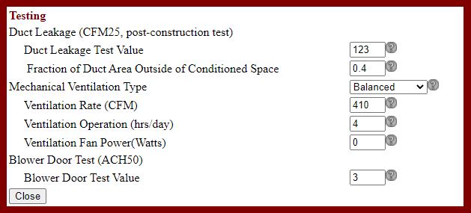

| **TITLE** | **PICTURE** | **RANGE** | **GUIDANCE** | **NOTES** |
| --- | --- | --- | --- | --- |
| **Duct Leakage** **Test Value**  (Leakage to the Outdoors @ cfm25, Post-Construction Test) | Duct Blaster | 0 ≤ cfm@25 ≤ max {10, 4 CFM25 per 100 sq ft} | Enter the expected results from the duct tightness test for the proposed unit. | The IECC 2015 (Section R403.3.4) requires the duct total leakage should be less than or equal to 4 cubic feet per minute per 100 square feet of conditioned floor area where the air handler is installed at the time of the test. Where the air handler is not installed at the time of the test, the total leakage shall be less than or equal to 3 cubic feet per minute per 100 square feet of conditioned floor area. The post-construction leakage less than or equal to 4 cubic feet per minute per 100 square feet of conditioned floor area |
| **Fraction of Duct Area Outside of Conditioned Space** |  | 0 - 1 | Input 0 for a house with ductwork completely in conditioned space. Otherwise, input the fraction (0.5 to 1) of the duct area located outside of conditioned space. |  |
| **Blower Door**  (@ ACH50) | Blower Door | 0 ≤ ACH@50 < 5 | Please enter the expected results from the Blower Door test for the proposed unit. | Infiltration must match requirements in 2015 IECC for ACH50 rates to be less than or equal to (2015 IECC Section R402.4.1.2): 5 ACH50 for Climate Zone 2  Infiltration must match requirements in 2015 IECC for ACH50 rates to be less than or equal to (2015 IECC Section R402.4.1.2): 3 ACH50 for Climate Zone 3 & 4. But in NCTCOG area can the maximum can be 4 ACH50. |
| **Mechanical Ventilation Type** |  | *Drop Down Menu:*   * NONE * Balanced * Exhausted Only | Select the type of mechanical ventilation: none, balanced, exhaust only/supply only. | -None: No mechanical ventilation system is used.  -Balanced: Balanced mechanical ventilation system uses a mechanical fan to adjust air supply and exhaust for meeting design specifications.  -Exhaust only: Exhaust only mechanical ventilation system uses a mechanical fan to make negative pressure in a room.  -Supply only: Supply only mechanical ventilation system uses a mechanical fan to make a positive pressure in a room |
| **Ventilation Rate (CFM)** |  | *Minimum:* (0.01\*CFA+7.5\*(Nbr+1) [CFM]) / (Ventilation operation [hrs/day] / 24)  *Maximum:* 700 | Enter the mechanical ventilation rate in Cubic Feet per Minute (CFM). CFM is a standard measurement of airflow. | The mechanical ventilation rate must be higher than or equal to <[CFM]) / (Ventilation operation [hrs/day] / 24)> CFM based on 2015 IECC Section R403.6 (2015 IRC Section M1507.3.3). |
| **Ventilation Operation (hrs/day)** |  | 1-24 | Enter the number of operation hours per day for the mechanical ventilation. | Daily operation range must be between 1 and 24 hours. |
| **Ventilation Fan Power(Watts)** |  | *Minimum:* 0  *Maximum:*  Fan power (Watt) = (MV Rate [CFM]) / (2.8 [CFM/Watt]) | Enter the blower fan power to operate the mechanical ventilation in Watts. | Mechanical ventilation fan efficacy must be higher than or equal to 2.8 CFM/Watt for in-line fans (2015 IECC Table R403.6.1). |

The Testing Supplemental Panel allows input of basic testing values. Not all fields in the example above will appear on this project, only the testing fields applicable to this project will appear.

Duct Tightness tests are to be performed at CFM25, post-construction. Blower Door tests are to be performed at ACH50. When a pre-construction certificate is needed, select the ‘Tested’ option and enter an estimated value in these fields. When the actual results are available, edit these fields to get a final post-construction energy report.

Note: There are only 2 options in IC3 4.0, which are ‘Tested’ and ‘Not Tested’. The value should be set to ‘Tested’ for IECC 2015 and higher. The ‘Not tested’ option is retained for use in imported projects only.

Mechanical Ventilation, when needed, has limits to its input values that are intricately connected to other fields in the project. Changing other fields in the project may alter the minimum or maximum values allowed. It is recommended to enter all other values in the project, before correcting any errors in these fields.

Important: The Mechanical Ventilation is checked against the mechanical code to ensure enough fresh air is entering the house. There is a minimum CFM/day needed to meet this code. The product of the Ventilation rate times Operation hours must be greater than this value. If it is not, then you will see an error message stating that the CFM/day in not high enough and will be given the ventilation rate needed to reach the needed value **at the same operation hours.** Often, this in not the best way to resolve the issue. But instead, the correct solution is to increase the operation hours until the product of ventilation rate and operation hours meets the requirement. Always place the listed ventilation rate of your mechanical ventilation equipment, and adjust the hours as needed to meet the requirements (up to 24 hours/day, of course)

### Roof

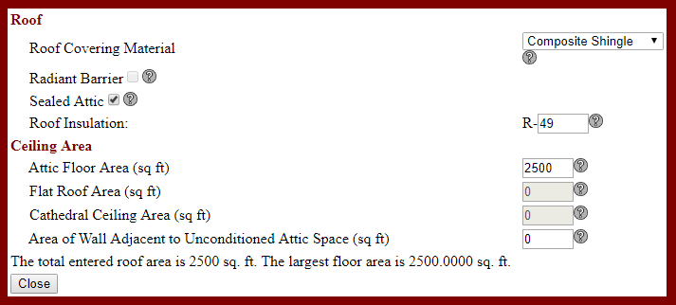

Roof details are entered on the Roof Supplemental Panel.

Note: the total celling area must be equal to or larger than the conditioned floor area of the top floor. The **Floor Plan Details** should be completed prior to the Roof Panel.

| **TITLE** | **PICTURE** | **RANGE** | **GUIDANCE** | **NOTES** |
| --- | --- | --- | --- | --- |
| **Roof Covering Material** |  | *Drop Down Menu:*   * Clay or Concrete Tile * Comp Shingle * Metal * Slate * Wood Shingles * Other | Select the type of roof covering for the proposed unit. | This field uses the type of roof covering material to estimate the reflectivity and absorbance properties of the roof. |
| **Radiant Barrier** | Radiant Barrier | *Check Box:*   * Checked - Yes * Unchecked - No | Select option according to the construction specifications for the roof assembly. | This field uses the specifications of the layer of material under the roof surface to estimate the reflectance and emissivity of the interior surface of the roof assembly. |
| **Sealed Attic** | attic_floor_area.gif | *Check Box:*   * Checked - Yes * Unchecked - No | Select if a sealed attic is used (no other roof types but attic are allowed in this case. The flat roof and cathedral roof area inputs are not applicable). | Duct systems are always treated as being in the conditioned space when using a sealed attic (see Table R405.5.2(2)). |
| **Roof Insulation R-Value** | Total Roof/Ceiling Insulation R-Value | 13 – 60 | Enter the weighted average R-Value for the roof/ceiling cavity insulation. | Insulation R-values are verified at inspection.  Regardless of the type of insulation, the value here reflects the cavity insulation installed at the ceiling or the roof.  Appropriate R-values can be found in Table R402.1.2 of the IECC 2009. |
| **Attic Floor Area**  (sq ft) | attic_floor_area.gif | 0 – 30,000 (ft2) | Enter the square footage of the attic area (measured horizontally). |  |
| **Flat Roof Area**  (sq ft) | flat_roof.gif | 0 – 30,000 (ft2) | Enter the square footage of the ceiling area covered by a flat roof. |  |
| **Cathedral Ceiling Area**  (sq ft) | Cathedral_Ceiling.gif | 0 – 30,000 (ft2) | Enter the square footage of the cathedral ceilings. |  |
| **Area of Wall Adjacent to Unconditioned Attic Space**  (sq ft) | knee_wall.gif | 0 – 10,000 (ft2) | Enter the square footage of any walls adjacent to unconditioned attic space. | The calculator assigns the wall R-value to these walls. |

### Foundation



Data about the foundation is entered on the Foundation Supplemental Panel.

| **TITLE** | **PICTURE** | **RANGE** | **GUIDANCE** | **NOTES** |
| --- | --- | --- | --- | --- |
| **Foundation Type** |  | *Drop Down Menu:*   * Slab On Grade * Pier and Beam * Raised Floor | Select the type of foundation the unit will have. | If “Slab On Grade” is selected then “Add Slab Insulation” appears in lieu of the Floor Insulation Field.  IC3 doesn’t model basements at this time. |
| **Foundation Insulation** |  | 0 – 20 | Enter the R-value of the Foundation insulation. | This Foundation insulation for “Pier and Beam” and “Raised Floor” options is floor insulation.  The Foundation insulation for “Slab on Grade” floor type option is slab insulation.  Appropriate R-values can be found in Table R402.1.2 of the IECC 2015. |

### Heating

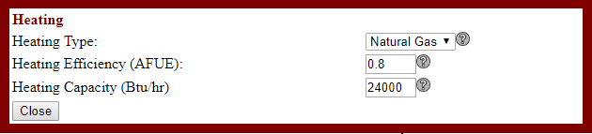

Information on the central heating system is entered on the Heating Supplemental Panel.

| **TITLE** | **PICTURE** | **RANGE** | **GUIDANCE** | **NOTES** |
| --- | --- | --- | --- | --- |
| **Heating Type** |  | *Drop Down Menu:*   * Natural Gas * Heat Pump * Electric Resistance\* | Select the heating type for the unit (e.g., heat pump, natural gas). | The software assumes that the space cooling equipment is electric.  The “Heat Pump” option is provided with a backup electric resistance heating.  \* “Electric Resistance” is not allowed when the “IECC 2015 Austin” option is selected. |
| **Heating Efficiency**  **(AFUE / HSPF)** |  | For AFUE 0.6 – 1  For HSPF 7.7 – 12 | Enter either the Annual Fuel Utilization Efficiency (AFUE) or Heating Seasonal Performance Factor (HSPF) depending on the “Heating Type” selected. | Note that the label changes based on your heating type, and that if you enter an AFUE value, and change the heating type, you will see a reminder that the fractional AFUE isn’t an acceptable HSPF value.  In case of “Electric Resistance” option being selected, the efficiency of the heater is fixed by the IC3 at 100%. |
| **Heating Capacity (Btu/hr)** | HVAC Sizing | 12,000 – 180,000 | Enter the Heating Capacity of the heater in Btu/ hour. | Equipment must be sized according to method acceptable to the building official or authority having jurisdiction. |

### 

### A/C

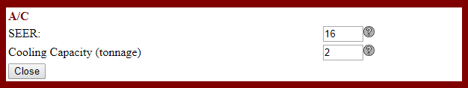

Information on the central A/C system is entered on the A/C Supplemental Panel.

Note: IC3 requires central air and heating. The program is not designed to evaluate other types of systems.

| **TITLE** | **PICTURE** | **RANGE** | **GUIDANCE** | **NOTES** |
| --- | --- | --- | --- | --- |
| **SEER**  **(A/C Efficiency)** |  | 13 – 21 | Enter the Seasonal Energy Efficiency Ratio (SEER) of the air-conditioner. | This entry applies to Heat Pumps too. |
| **Cooling Capacity**  **(tonnage)** | HVAC Sizing | 1.0 – 15.0  (tons) | Enter the tonnage of the air-conditioner. | Equipment must be sized according to method acceptable to the building official or authority having jurisdiction. |

### Water Heater EF input for 2015 IECC, 2015 IECC AE, 2015 IECC NCTCOG, and IECC 2018

Energy Factor (EF): An older measure of water heater overall efficiency that is being phased out due to new test methods for water heaters. The higher the EF value is, the more efficient the water heater. EF is determined by the Department of Energy’s test method outlined in the 10 CFR parts 200 to 499 edition revised as of January 1, 2014.

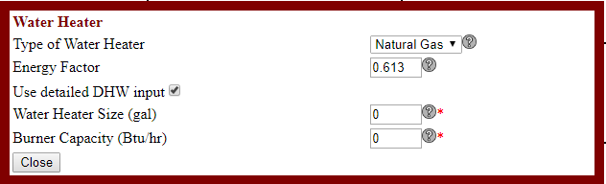

### Water Heater UEF input for 2015 IECC AE, 2021 IECC, and 2021 AE

**Uniform Energy Factor (UEF):**  The newest measure of water heater overall efficiency. The higher the UEF value is, the more efficient the water heater. UEF is determined by the Department of Energy’s test method outlined in 10 CFR Part 430, Subpart B, Appendix E.

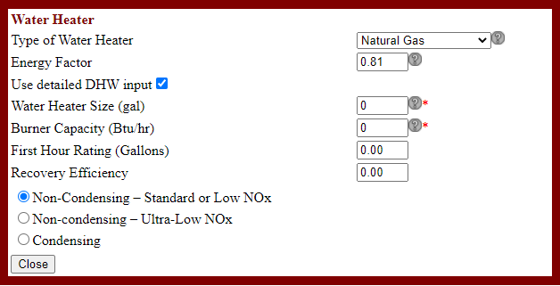

Information on the water heater is entered on the Water Heater Supplemental Panel.

Data entry for the details of each individual water heater when multiple water heaters are used is not permitted. Data shall be averaged for the multiple units and entered as one.

| **TITLE** | **PICTURE** | **RANGE** | **GUIDANCE** | **NOTES** |
| --- | --- | --- | --- | --- |
| **Type of Water Heater** |  | *Drop Down Menu:*   * Natural Gas * Electric * Heat Pump * Tankless NGas * Tankless Electric | Select the type of fuel the water heater uses. |  |
| **Energy Factor** |  | For Water Heater Type Electric: 0.97 - 0.00132 \* vol to 1.0  For Water Heater Type Natural Gas: 0.67 - 0.0019 \* vol to 0.96  For Water Heater Type Heat Pump: 2.057-0.00113 \* vol to 2.406-0.00113\*vol | Enter the Energy Factor (EF) for the water heating equipment to be installed in the proposed unit. | The software works with both tank-type and tank-less water heaters.  If you have more than one water heater, please do a weighted average of the units, or use the efficiency rating of the least efficient water heater here.  Equations providing minimum requirements of EF can be found in Table R404.2 of the IECC 2015. |
| **Water Heater Size (gal)** |  | 20 - 120 | Enter the size of the water heater. | This field automatically appears if the user clicks “Use detailed DHW input” box. |
| **Burner Capacity (Btu/hr)** |  | Gas DHW: 30000 to 70000  Electric DHW: 800 to 5500  Heat Pump DHW: N/A | Enter the burner capacity of the water heater. | This field automatically appears if the user clicks “Use detailed DHW input” box. |
| **First Hour Rating (Gallons)** |  | 0 - 120 | The First Hour Rating (FHR) is an estimate of the maximum volume of hot water in gallons that a storage water heater can supply within an hour that begins with the water heater fully heated. |  |
| **Gallons per Minute (gallons/minute)** |  | 0 - 12 | Gallons per Minute (GPM): The number of gallons per minute of hot water that can be supplied by an instantaneous water heater while maintaining a nominal temperature rise during steady state operation. |  |
| **Recovery Efficiency** |  | 0 - 1 | Recovery Efficiency is a fraction that refers to the amount of water heated to a set temperature per hour. |  |
| **Natural Gas Burner Distinguishing Criteria** |  | * Non-Condensing – Standard or Low NOx * Non-condensing – Ultra-Low NOx * Condensing |  |  |

### 

### Appliances (ERI mode only)

2015 and 2018 version

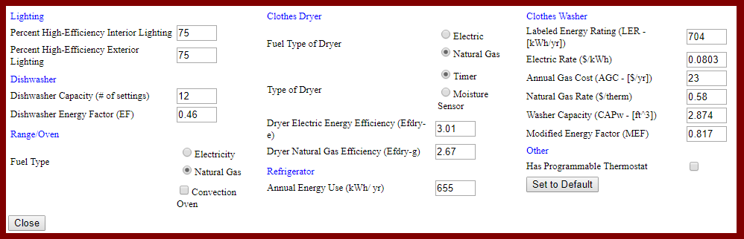

2021 version

Appliance and lighting information is entered on the Appliance Supplemental Panel.

The Set to Default button will set all values in this panel to default values as determined by the IECC and the National Appliance Energy Conservation Act.

This panel will only appear in ERI mode, as this data has no impact on the IECC Simulated Performance path.

## Floor Plan Details

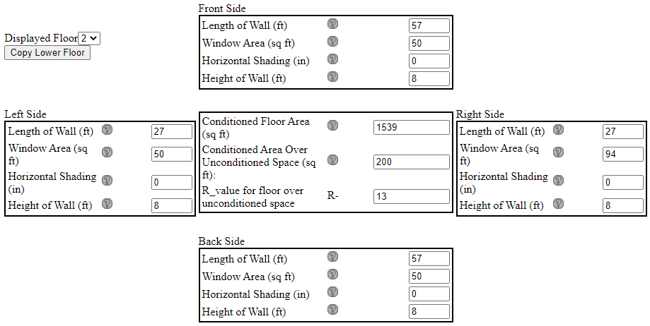

The right side of the data entry screen shows a graphical representation of the residential data by floor level.

The Displayed Floor entry shows which floor level of the residence is currently displayed in the graphic. The first floor values must be entered. Additional floor levels may be added by entering the data separately or by selecting the ‘copy lower floor’ button, which will import the data from the floor level directly below.

| **TITLE** | **PICTURE** | **RANGE** | **GUIDANCE** | **NOTES** |
| --- | --- | --- | --- | --- |
| **Front/Right/Back/Left**  **(ft)** |  | 0 - 200  (ft.) | Enter the distance measured from the wall to the outer edge of the projection. | The projections are located at the roof level, and provide shade to both the windows and to the walls. It is ok to enter values here as well as the Conditioned over non-Conditioned question on the Floors Tab. These are focused on shading of the windows; the other is focused on thermal loss through the exposed floor. Enter the horizontal distance (ft) from the wall to the edge of the overhang, eave, or permanently attached shading device on this side of the unit for this floor.  If you enter measurements in inches, the software will convert to feet and inches.  These inputs are repeated for any 2nd or 3rd floors. |
| **Front / Right / Back / Left Window area**  **(sq ft)** |  | \* ≥ 0  (ft.2) | Enter the total combined area of all windows and glass doors; measured using the rough opening and including the sash, curbing or other framing elements. For doors where the daylight opening is less than 50% of the door area, the glazing area is the daylight opening area only. For glass doors, the glazing area is the rough opening area for the door including the door and frame. | Make sure your directions (front, back, left, and right) correspond to the orientation of the unit.  For doors where the glazing area is less than 50% of the rough opening of the door area, the glazing area entered is the actual glazing area only.  For doors where the glazing area is 50% for more of the rough opening of the door area, the glazing area entered is the rough opening area for the door including the door and frame.  These fields are repeated for the each floor selected. |
| **Horizontal Shading (in)** |  | 0 - 480 | Enter the distance measured from the wall to the outer edge of the projection. |  |
| **Height of Wall (ft)** |  | 6.67 – 40  (ft.) | Enter the average ceiling height for this floor. | This value should be a weighted average of the ceiling heights. The impact from averaging is not large relative to the other fields the builder is providing.  If a two-story unit has a foyer or a room on the first floor that is two storied in height, then the ceiling height input for this space will be the same as the input value for the rest of the average ceiling height.  This field is repeated for the each floor selected. |
| **Conditioned Floor Area (sq ft)** |  | >100 | Enter the square-footage of conditioned space on each floor. |  |
| **Conditioned Area Over Unconditioned Space (sq ft):** |  | >0 | Enter the square-footage of conditioned space of this floor overhanging ambient (unconditioned) air. (i.e., 2nd or 3rd floor overhanging an unconditioned porch or garage.) |  |
| **R\_value for floor over unconditioned space** |  | 0 - 20 | Enter the R-Value of the floor insulation over unconditioned space. |  |

On each of the four sides you must enter data for that side:

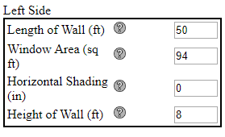

* IC3 requires a rectangular residence. Changing the ‘Length of Wall’ field for a given wall will also set the opposite wall’s length to the same value. For residences that are not rectangles, use the smallest dimensions that the residence will fit.
* IC3 requires a level ceiling. Changing the ‘Height of Wall’ field will set all walls to the same height. For houses with a non-uniform ceiling height, use the average height across the residence.
* ‘Window Area’ may not be larger than the calculated wall area based on the wall length and height

In the center of the graphic is the general size data for this floor level:

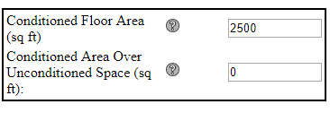

* ‘Conditioned Floor Area’ may not be larger than calculated maximum based on the wall length.
* For all stories above the first, the ‘Conditioned Area over Unconditioned Space’ field appears. The following formula must be meet for the IC3 to consider the project valid:

<Conditioned Floor Area> - <Conditioned Area over Unconditioned Space> = < Conditioned Floor Area> of lower floor.